# **1**

1. **Ga boven in naar “Tools”.**
2. **Druk vervolgens op “Options”.**
3. **Druk op “Text Editor”.**
4. **Vervolgens drukt u op “All Languages”.**
5. **Vink “Line numbers”.**

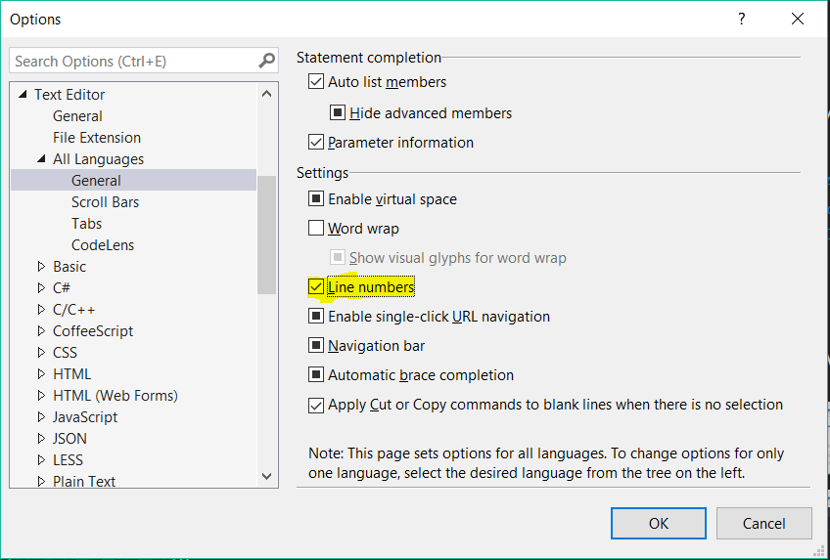

# 2

1. **Druk op “Tools”.**
2. **Druk vervolgens op “Options”.**
3. **Druk daarna “Projects and Solutions”.**
4. **Ten slotte drukt op de “3 puntjes” en kies uw locatie.**

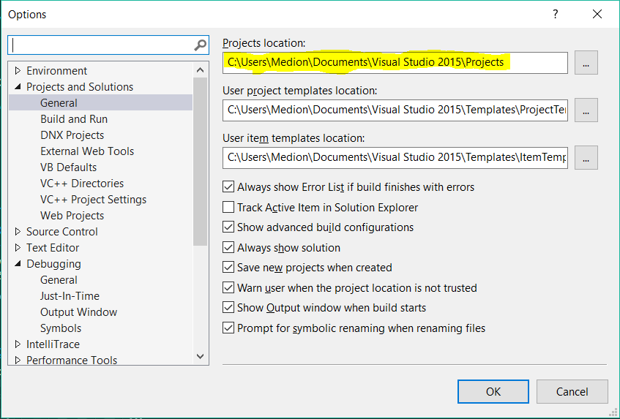

# **3**

ASP.NET

PHP

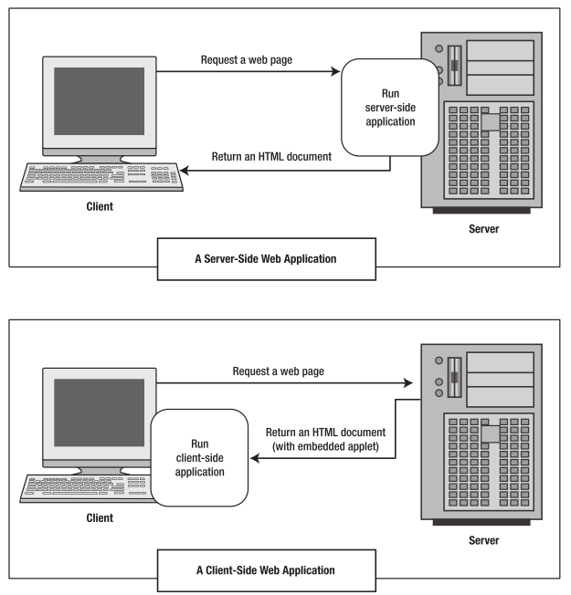

JavaScript

Flash

# **4**

[**ASP.NET VS PHP**](http://www.slashcoding.com/comparison-between-php-and-asp/)

***Comparison Aspects***

**Features and Extend-ability: PHP and ASP.NET have more or less the same features and what can be done in PHP can be done in ASP.NET as well.**

**Security: Both the languages provide more or less the same level of security. It all depends upon the programmer to which extent the security is implemented.**

**Development Time: Development time is something that depends upon the expertise of the programmer. If the programmer is efficient in PHP, obviously the development time in PHP would be less as compared to the time in ASP.NET. Though, for small projects, it is recommended that PHP be used so that the total cost incurred is less.**

**Framework: The number of frameworks available for PHP are a lot more than the ones available for ASP.NET. The frameworks for ASP.NET are developed by Microsoft, while for PHP, anyone can develop a framework.**

**Cost: Ultimately, in most cases, cost is the deciding factor. Now here, the cost refers to the development cost and the maintenance cost. Clearly, the development and running cost for PHP is less than the cost for ASP.NET.**